Student Name: Frederick Nguyen
Student Id: 016467373
Student Name: Ali Halmamat
Student Id: 017505410

A. Coding
Shell1.c
/**
* Description:
* --------------
* This program implements a minimal shell for Assignment 3.
*
* When the user types:
*
* ./countnames file1.txt file2.txt file3.txt
*
* The shell will:
* - Fork once per input file
* - Each child executes ./countnames on ONE file
* - Redirect stdout to PID.out
* - Redirect stderr to PID.err
* - Parent waits for all children (parallel execution)
*
* This removes all APUE dependencies and uses standard POSIX calls.
*/

#include <stdio.h>
#include <stdlib.h>
#include <string.h>
#include <unistd.h>
#include <sys/wait.h>

#define MAX_LINE 1024
#define MAX_ARGS 256
#define MAX_NAMES 300

typedef struct {
char name[30];
int count;
} NameCountData;

typedef enum {
TYPE_NAMECOUNT,
TYPE_B
} MessageType;

typedef struct {
MessageType type;
size_t size;
} MessageHeader;

typedef struct {
pid_t pid;
int read_fd;
} ChildPipe;

static int split_line(char *line, char *argv[], int max_args) {
int argc = 0;
char *tok = strtok(line, " \t");
while (tok != NULL && argc < max_args - 1) {
argv[argc++] = tok;
tok = strtok(NULL, " \t");
}
argv[argc] = NULL;
return argc;
}

static int is_countnames_cmd(const char *cmd) {
return strcmp(cmd, "./countnames") == 0 || strcmp(cmd, "countnames") == 0;
}

static void add_or_sum(NameCountData totals[], int *distinct, const NameCountData *item) {
for (int i = 0; i < *distinct; i++) {
if (strcmp(totals[i].name, item->name) == 0) {
totals[i].count += item->count;
return;
}
}

if (*distinct < MAX_NAMES) {
strncpy(totals[*distinct].name, item->name, sizeof(totals[*distinct].name) - 1);
totals[*distinct].name[sizeof(totals[*distinct].name) - 1] = '\0';
totals[*distinct].count = item->count;
(*distinct)++;
}
}

static ssize_t read_all(int fd, void *buf, size_t count) {
size_t total = 0;
char *p = (char *)buf;

while (total < count) {
ssize_t n = read(fd, p + total, count - total);
if (n == 0) {
return (ssize_t)total; /* EOF */
}
if (n < 0) {
return -1;
}
total += (size_t)n;
}

return (ssize_t)total;
}

static void read_from_pipe(int fd, NameCountData totals[], int *distinct) {
MessageHeader header;

while (1) {
ssize_t n = read_all(fd, &header, sizeof(header));
if (n == 0) {
return; /* end of pipe */
}
if (n < 0 || n != (ssize_t)sizeof(header)) {
fprintf(stderr, "Error reading message header from pipe\n");
return;
}

switch (header.type) {
case TYPE_NAMECOUNT: {
NameCountData dataNC;

if (header.size != sizeof(NameCountData)) {
fprintf(stderr, "Invalid payload size for TYPE_NAMECOUNT\n");
return;
}

n = read_all(fd, &dataNC, header.size);
if (n < 0 || n != (ssize_t)header.size) {
fprintf(stderr, "Error reading NameCountData payload\n");
return;
}

add_or_sum(totals, distinct, &dataNC);
break;
}

case TYPE_B: {
/* future extension */
char discard[256];
size_t remaining = header.size;

while (remaining > 0) {
size_t chunk = remaining < sizeof(discard) ? remaining : sizeof(discard);
ssize_t got = read_all(fd, discard, chunk);
if (got <= 0) {
fprintf(stderr, "Error reading TYPE_B payload\n");
return;
}
remaining -= (size_t)got;
}
break;
}

default:
fprintf(stderr, "Unknown message type received: %d\n", header.type);
return;
}
}
}

int main(void) {
char line[MAX_LINE];

while (1) {
printf("%% ");
fflush(stdout);

if (fgets(line, sizeof(line), stdin) == NULL) {
break;
}

line[strcspn(line, "\n")] = '\0';

if (line[0] == '\0') {
continue;
}

if (strcmp(line, "exit") == 0 || strcmp(line, "quit") == 0) {
break;
}

char line_copy[MAX_LINE];
char *args[MAX_ARGS];

strncpy(line_copy, line, sizeof(line_copy) - 1);
line_copy[sizeof(line_copy) - 1] = '\0';

int argc = split_line(line_copy, args, MAX_ARGS);
if (argc == 0) {
continue;
}

if (!is_countnames_cmd(args[0])) {
pid_t other = fork();
if (other == 0) {
execvp(args[0], args);
_exit(1);
} else if (other > 0) {
waitpid(other, NULL, 0);
}
continue;
}

if (argc == 1) {
pid_t pid = fork();
if (pid == 0) {
char *cn_argv[] = { (char *)"./countnames", NULL };
execvp(cn_argv[0], cn_argv);
_exit(1);
} else if (pid > 0) {
waitpid(pid, NULL, 0);
}
continue;
}

ChildPipe children[MAX_ARGS];
int child_count = 0;
NameCountData totals[MAX_NAMES];
int total_distinct = 0;

for (int i = 0; i < MAX_NAMES; i++) {
totals[i].name[0] = '\0';
totals[i].count = 0;
}

/*
* PARALLEL PART:
* create all children first, do not wait here.
*/
for (int i = 1; i < argc; i++) {
int pipefd[2];

if (pipe(pipefd) < 0) {
perror("pipe");
continue;
}

pid_t pid = fork();

if (pid < 0) {
perror("fork");
close(pipefd[0]);
close(pipefd[1]);
continue;
}

if (pid == 0) {
close(pipefd[0]);

/*
* Replace stdout with write end of pipe.
* Child can now "print" / write to stdout and parent receives it.
*/
if (dup2(pipefd[1], STDOUT_FILENO) < 0) {
close(pipefd[1]);
_exit(1);
}

close(pipefd[1]);

char *cn_argv[] = { (char *)"./countnames", args[i], NULL };
execvp(cn_argv[0], cn_argv);
_exit(1);
}

close(pipefd[1]);
children[child_count].pid = pid;
children[child_count].read_fd = pipefd[0];
child_count++;
}

/*
* Wait for children after all are spawned.
* wait() returns PID of child that finished.
*/
int status;
pid_t pid;

while ((pid = wait(&status)) > 0) {
if (WIFEXITED(status)) {
fprintf(stderr,
"Child %d terminated normally with exit code: %d\n",
pid, WEXITSTATUS(status));
} else if (WIFSIGNALED(status)) {
fprintf(stderr,
"Child %d terminated abnormally with signal number: %d\n",
pid, WTERMSIG(status));
}

for (int i = 0; i < child_count; i++) {
if (children[i].pid == pid) {
read_from_pipe(children[i].read_fd, totals, &total_distinct);
close(children[i].read_fd);
children[i].read_fd = -1;
break;
}
}
}

/* print final aggregated result */
for (int i = 0; i < total_distinct; i++) {
printf("%s: %d\n", totals[i].name, totals[i].count);
}
}

return 0;
}

Countnames.c

/**
* Description:
* --------------
* countnames reads names from a file (or stdin) and counts
* how many times each name appears.
*
* Author names: Frederick Nguyen | Ali Halmamat
* Author emails: quangnguyen1705@gmail.com | ali.Halmamat@sjsu.edu
* Last modified date: 03/21/2026
* Creation date: 03/21/2026
* For Assignment 3:
* - This program processes ONE file at a time.
* - Output is written to stdout.
* - Warnings and errors are written to stderr.
* - The parent shell process redirects stdout/stderr
* to PID.out and PID.err.
*
*/

#include <stdio.h>
#include <stdlib.h>
#include <string.h>
#include <unistd.h>

#define MAX_NAMES 100
#define MAX_NAME_LEN 30
#define BUF_SIZE 256

typedef struct {
char name[30];
int count;
} NameCountData;

typedef enum {
TYPE_NAMECOUNT,
TYPE_B
} MessageType;

typedef struct {
MessageType type;
size_t size;
} MessageHeader;

static void strip_newline(char *s) {
size_t len = strlen(s);
while (len > 0 && (s[len - 1] == '\n' || s[len - 1] == '\r')) {
s[len - 1] = '\0';
len--;
}
}

static ssize_t write_all(int fd, const void *buf, size_t count) {
size_t total = 0;
const char *p = (const char *)buf;

while (total < count) {
ssize_t n = write(fd, p + total, count - total);
if (n <= 0) {
return -1;
}
total += (size_t)n;
}

return (ssize_t)total;
}

static int write_struct_namecount(int fd, const NameCountData *data) {
MessageHeader header;
header.type = TYPE_NAMECOUNT;
header.size = sizeof(NameCountData);

if (write_all(fd, &header, sizeof(header)) != (ssize_t)sizeof(header)) {
return -1;
}

if (write_all(fd, data, sizeof(NameCountData)) != (ssize_t)sizeof(NameCountData)) {
return -1;
}

return 0;
}

int main(int argc, char *argv[]) {
FILE *in = NULL;
FILE *outf = NULL;
FILE *errf = NULL;
char outname[64];
char errname[64];
pid_t pid = getpid();

NameCountData table[MAX_NAMES];
int distinct = 0;
char buf[BUF_SIZE];
int line_num = 0;
const char *src_label = "stdin";

for (int i = 0; i < MAX_NAMES; i++) {
table[i].name[0] = '\0';
table[i].count = 0;
}

snprintf(outname, sizeof(outname), "%d.out", (int)pid);
snprintf(errname, sizeof(errname), "%d.err", (int)pid);

outf = fopen(outname, "w");
if (outf == NULL) {
return 1;
}

errf = fopen(errname, "w");
if (errf == NULL) {
fclose(outf);
return 1;
}

if (argc == 2) {
src_label = argv[1];
in = fopen(argv[1], "r");
if (in == NULL) {
fprintf(errf, "error: cannot open file %s\n", argv[1]);
fclose(outf);
fclose(errf);
return 1;
}
} else if (argc == 1) {
in = stdin;
} else {
fclose(outf);
fclose(errf);
return 0;
}

while (fgets(buf, sizeof(buf), in) != NULL) {
line_num++;
strip_newline(buf);

if (strlen(buf) < 1) {
fprintf(errf, "Warning - file %s line %d is empty.\n", src_label, line_num);
continue;
}

if (strlen(buf) > MAX_NAME_LEN) {
buf[MAX_NAME_LEN] = '\0';
}

int found = 0;
for (int i = 0; i < distinct; i++) {
if (strcmp(table[i].name, buf) == 0) {
table[i].count++;
found = 1;
break;
}
}

if (!found) {
if (distinct >= MAX_NAMES) {
fprintf(errf, "error: too many distinct names\n");
if (in != stdin) {
fclose(in);
}
fclose(outf);
fclose(errf);
return 1;
}

strncpy(table[distinct].name, buf, sizeof(table[distinct].name) - 1);
table[distinct].name[sizeof(table[distinct].name) - 1] = '\0';
table[distinct].count = 1;
distinct++;
}
}

if (in != stdin) {
fclose(in);
}

/* write per-child result to PID.out */
for (int i = 0; i < distinct; i++) {
fprintf(outf, "%s: %d\n", table[i].name, table[i].count);
}

fclose(outf);
fclose(errf);

/*
* stdout of child has been redirected by shell.c into a pipe.
* So sending to STDOUT_FILENO sends data back to the parent.
*/
for (int i = 0; i < distinct; i++) {
if (write_struct_namecount(STDOUT_FILENO, &table[i]) < 0) {
return 1;
}
}

return 0;
}

B. Result and TestCase
Run compilation: gcc -o countnames countnames.c -Wall -Werror
gcc -o shell1 shell1.c -Wall -Werror
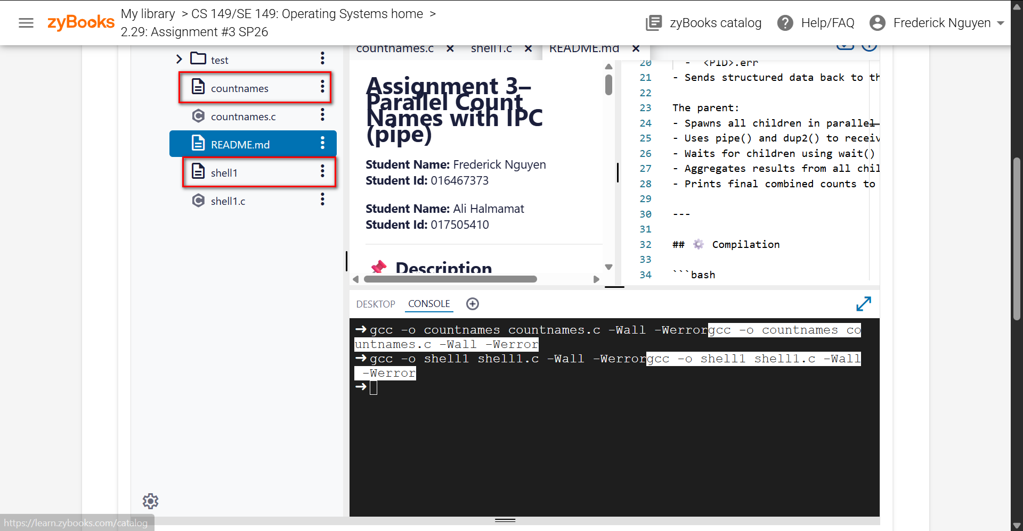

- Test Case 1 – Basic aggregation
Run Command: ./shell1
./countnames test/test1.txt test/test2.txt

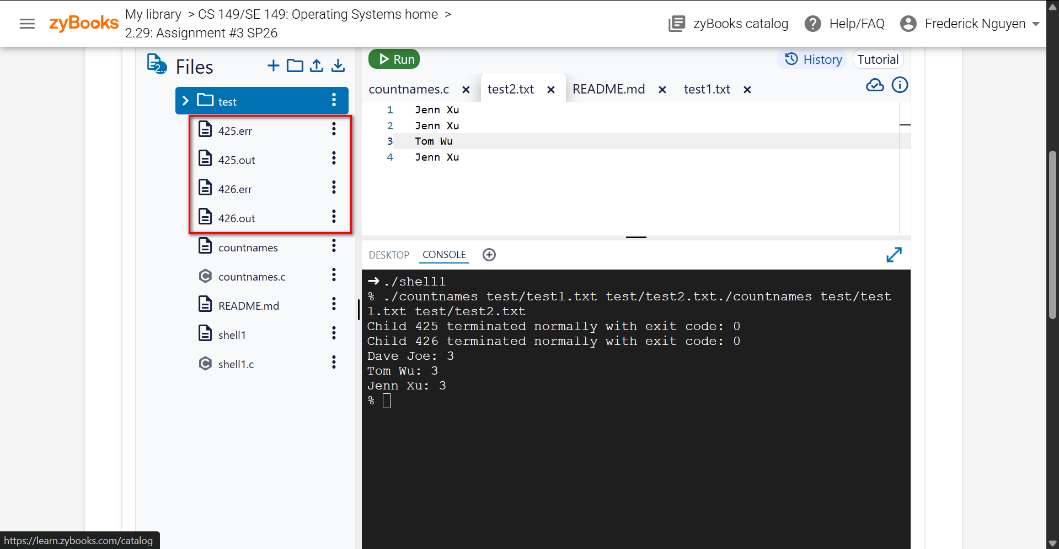

425.err

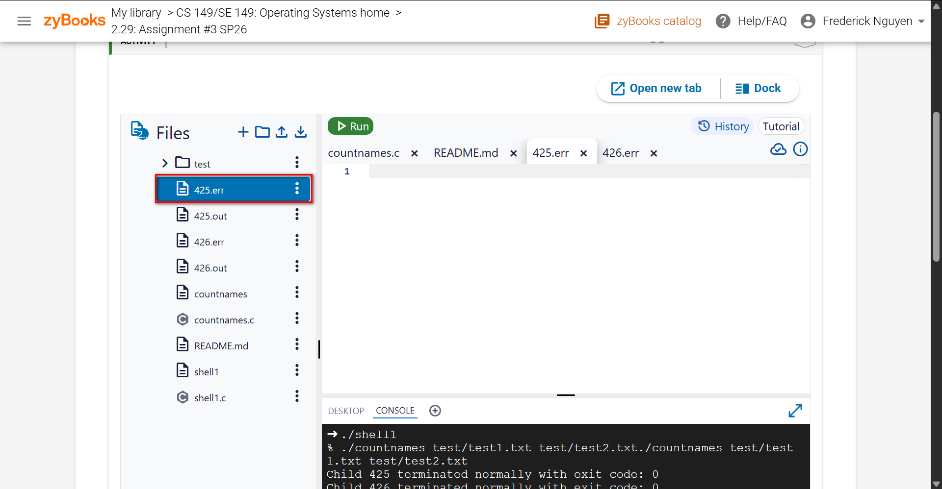
425.out

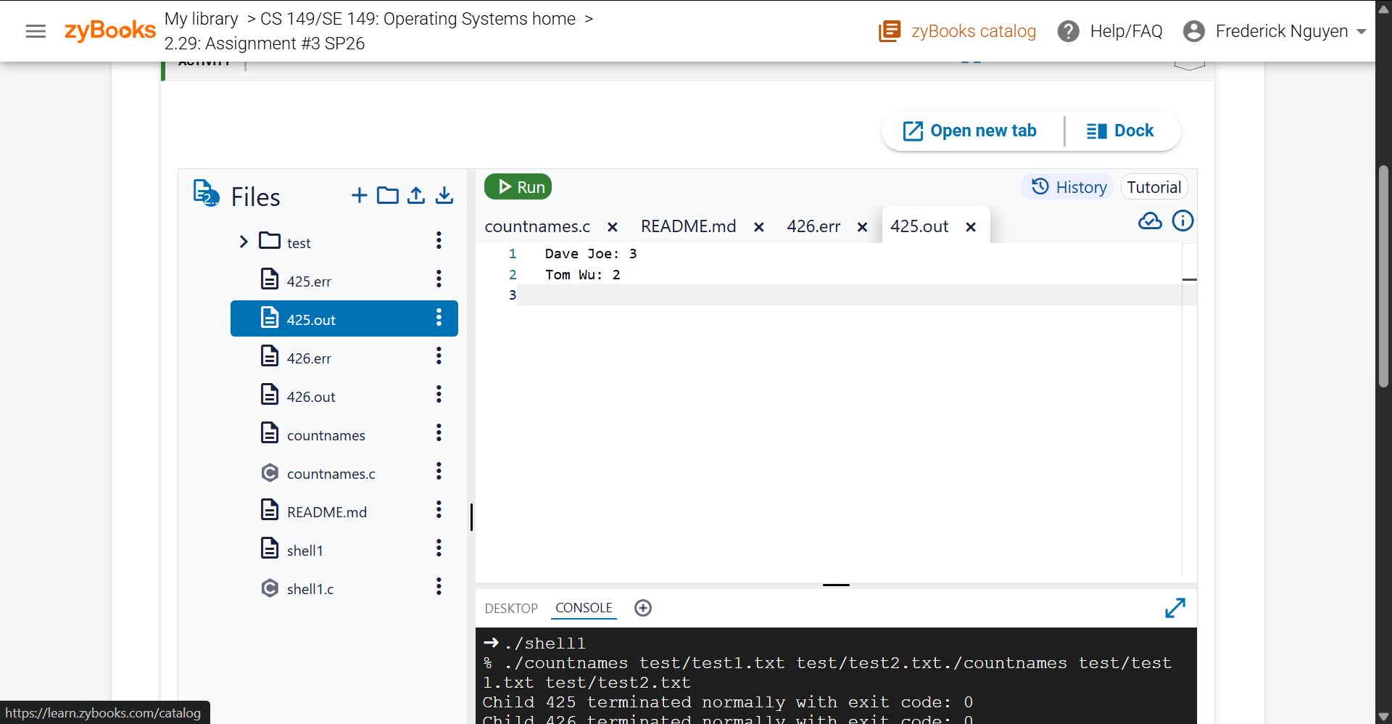

426.err
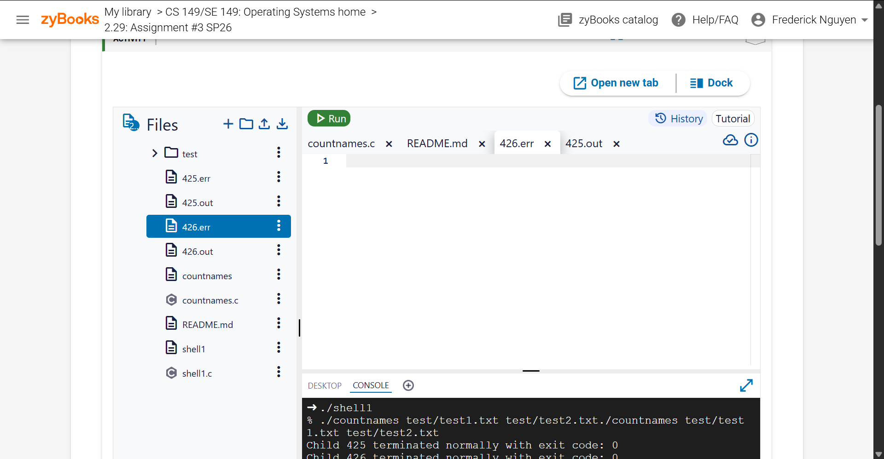
426.out
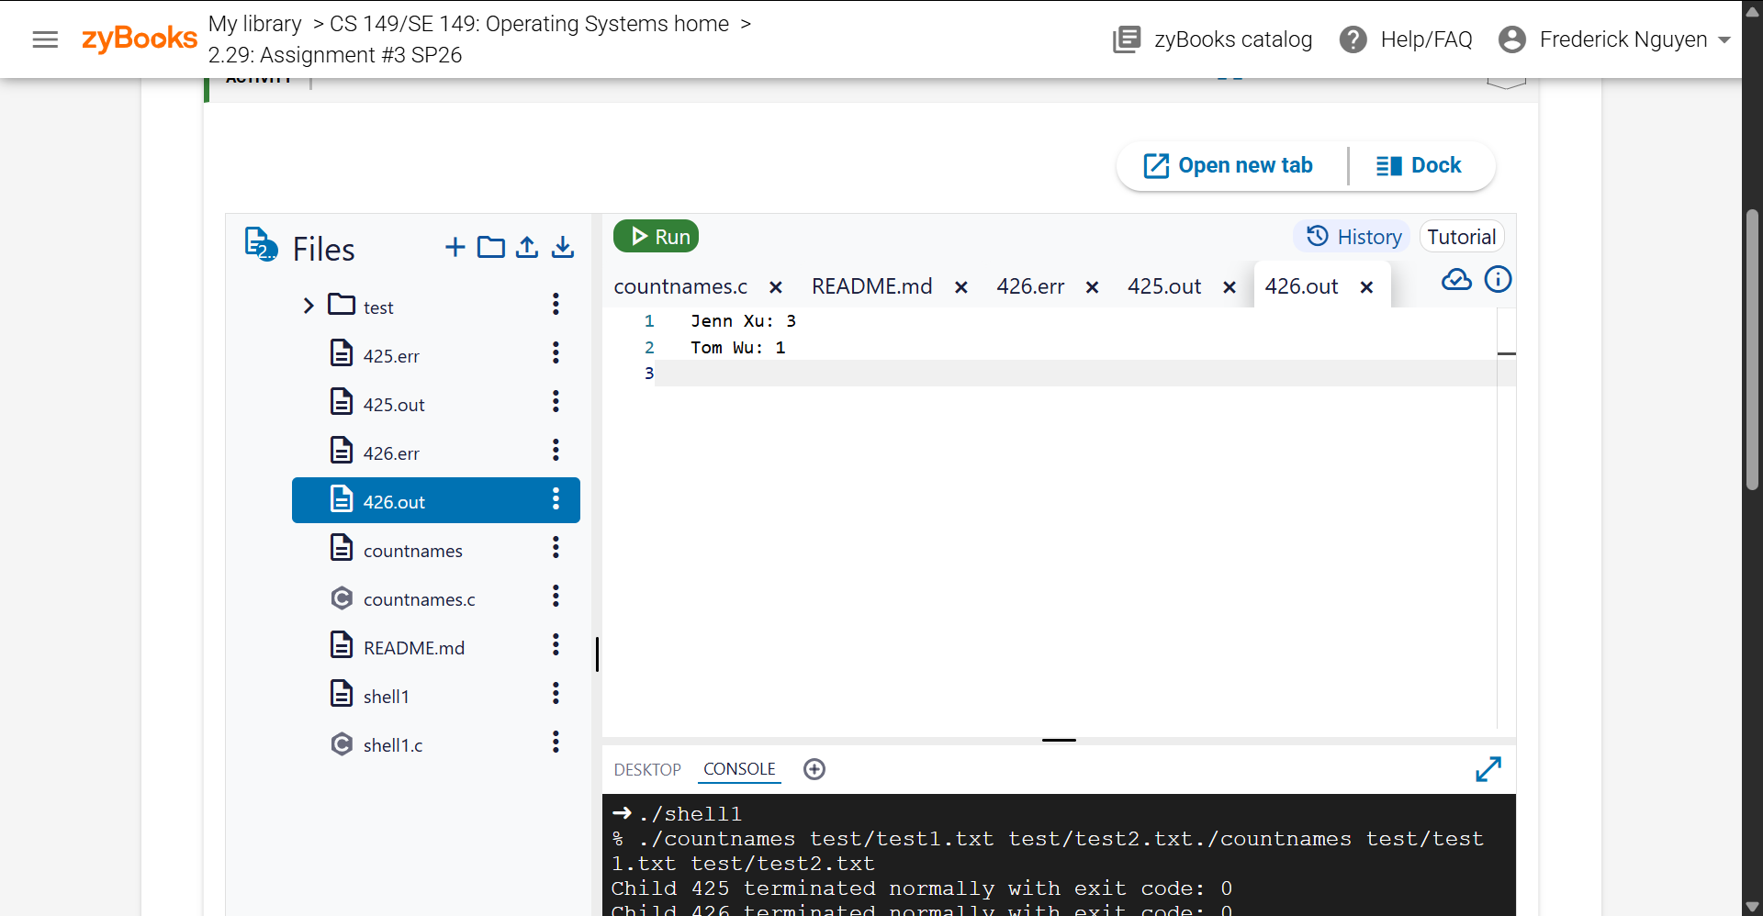

- Test Case 2 – Test Case 2 – Missing file.
Run command: ./shell1
./countnames test/missing.txt test/names1.txt

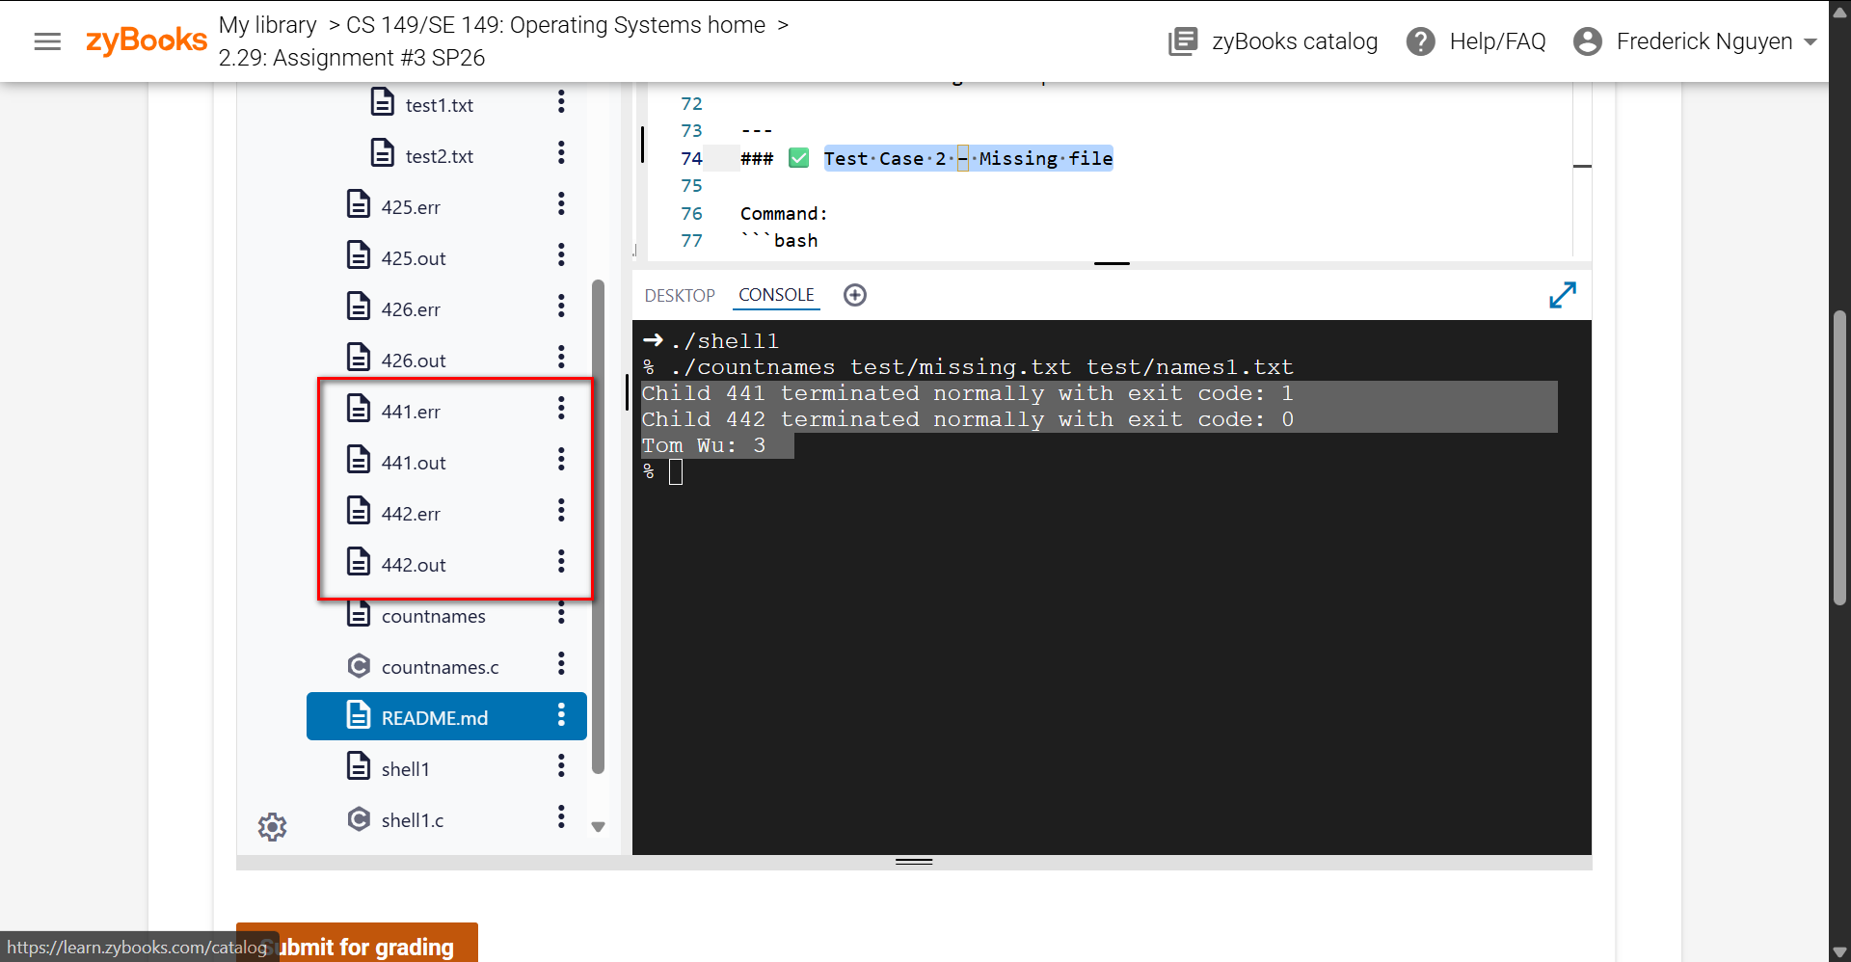

441.out
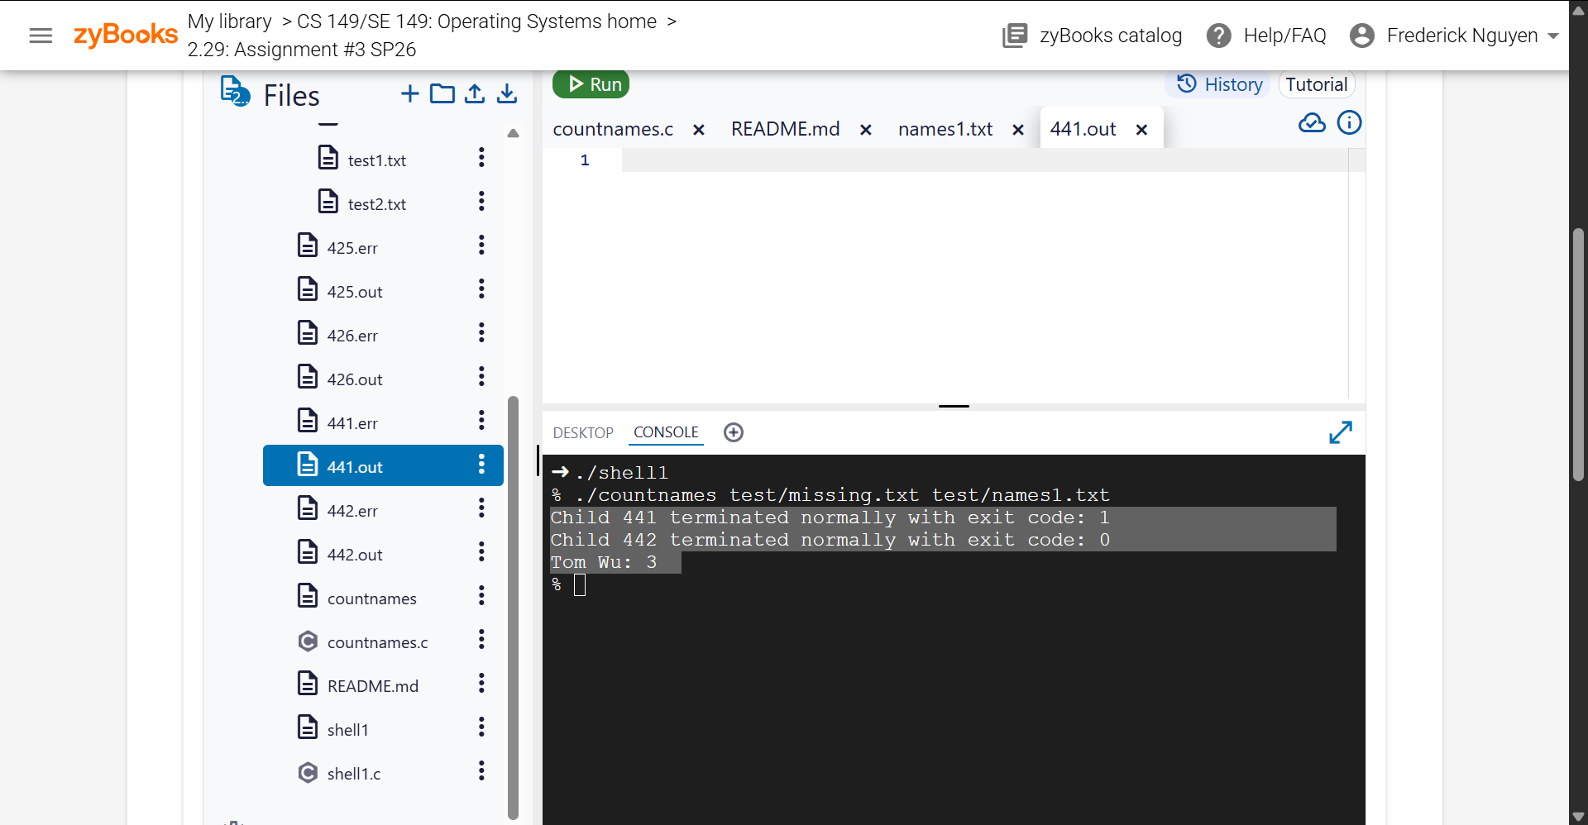

441.err
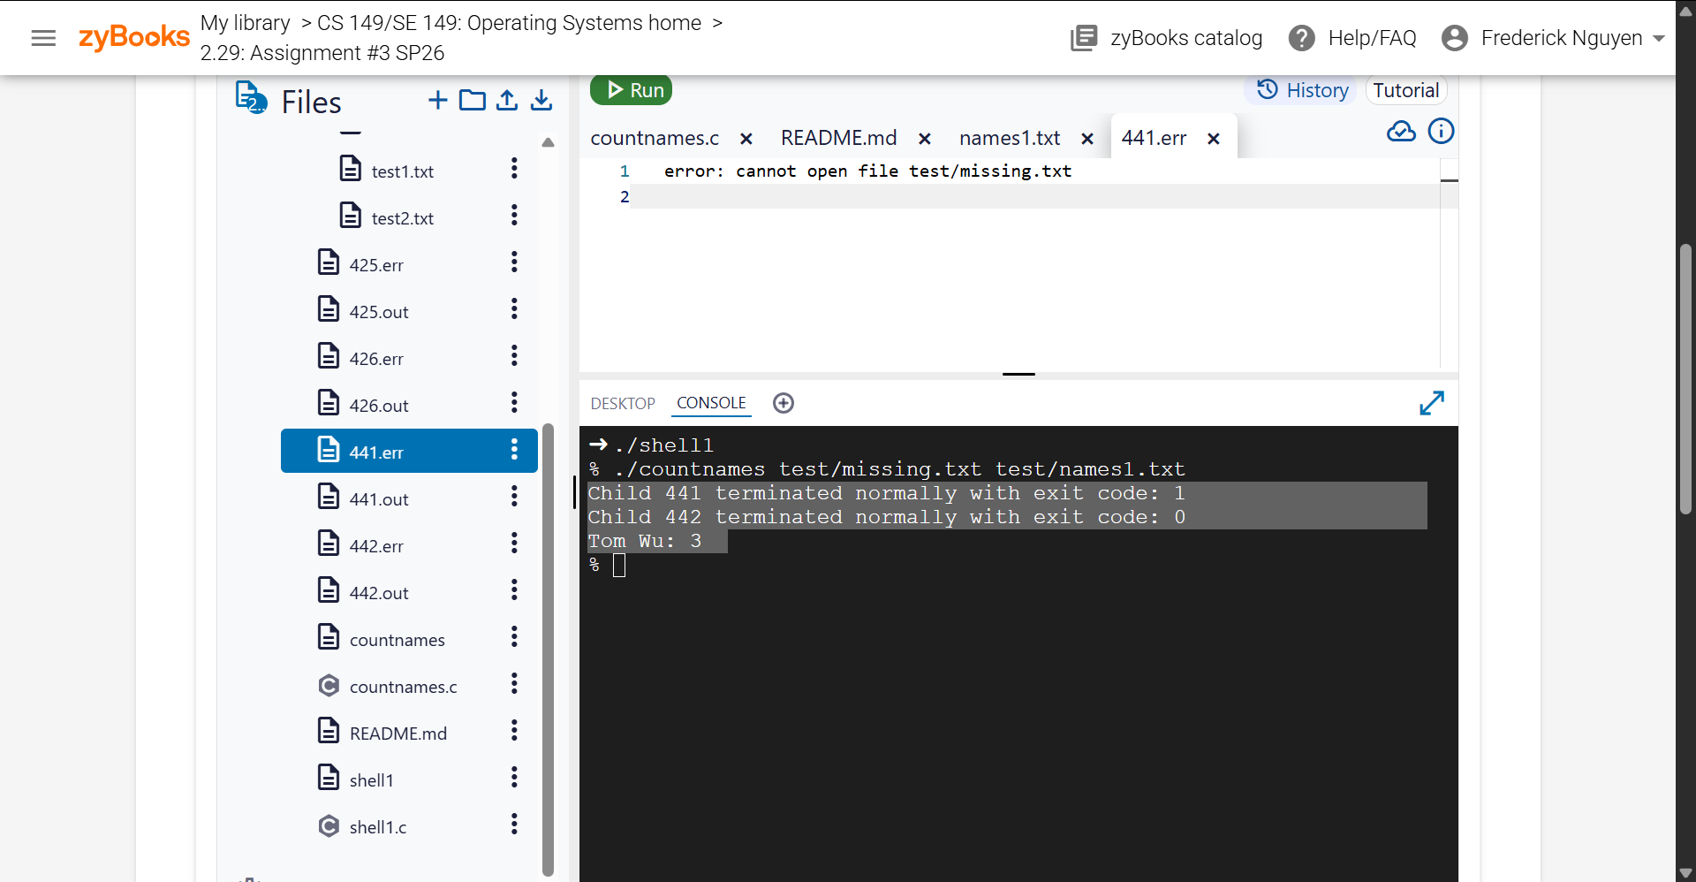

442.out

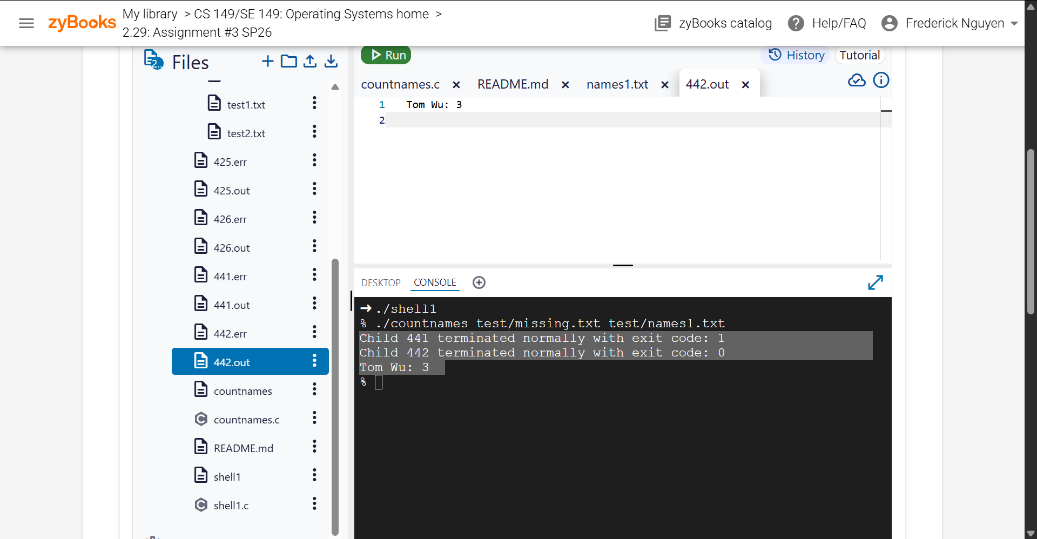

442.err

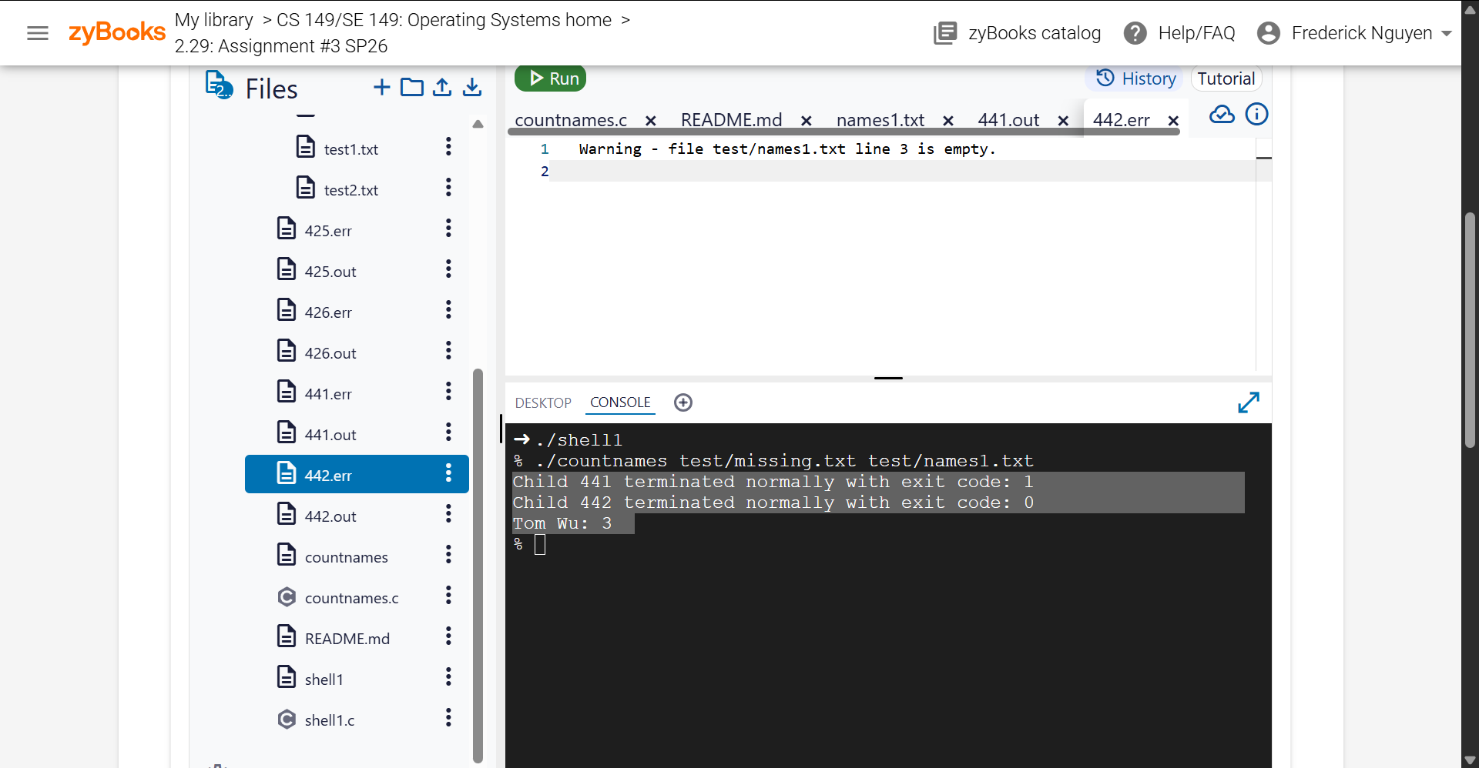

- Test Case 3 – Single file
Run Command: ./shell1
./countnames test/name2.txt

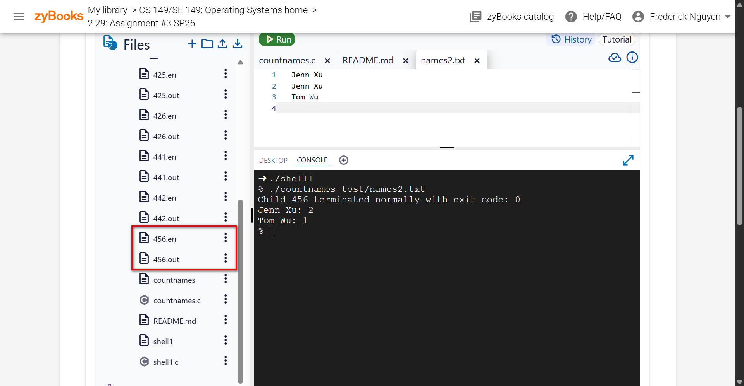

456.err
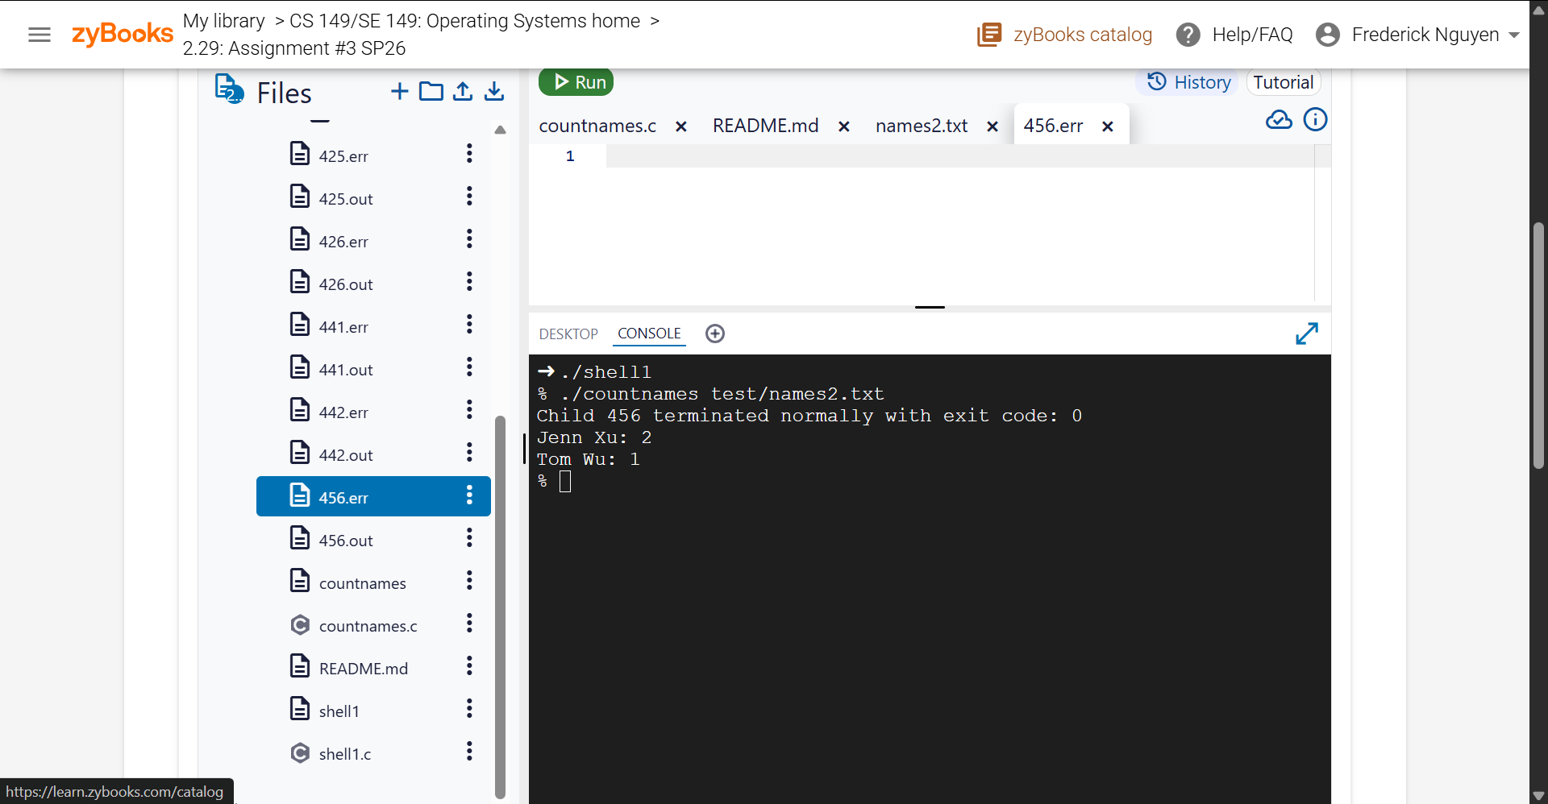

456.out
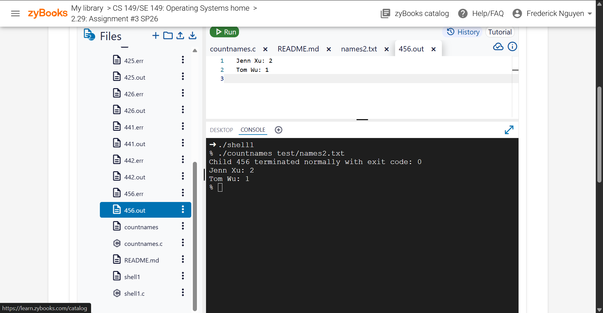

- Test Case 4 – Empty line handling
Run Command: ./shell1
./countnames test/name2.txt

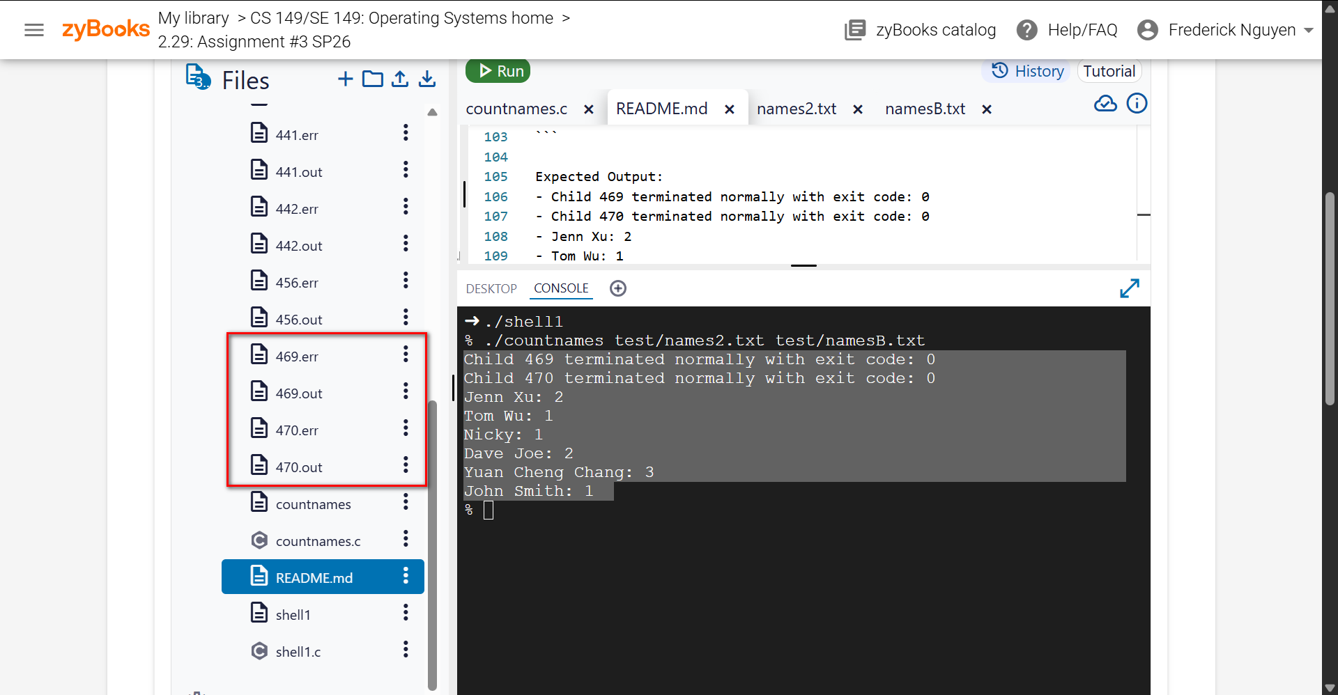

469.err

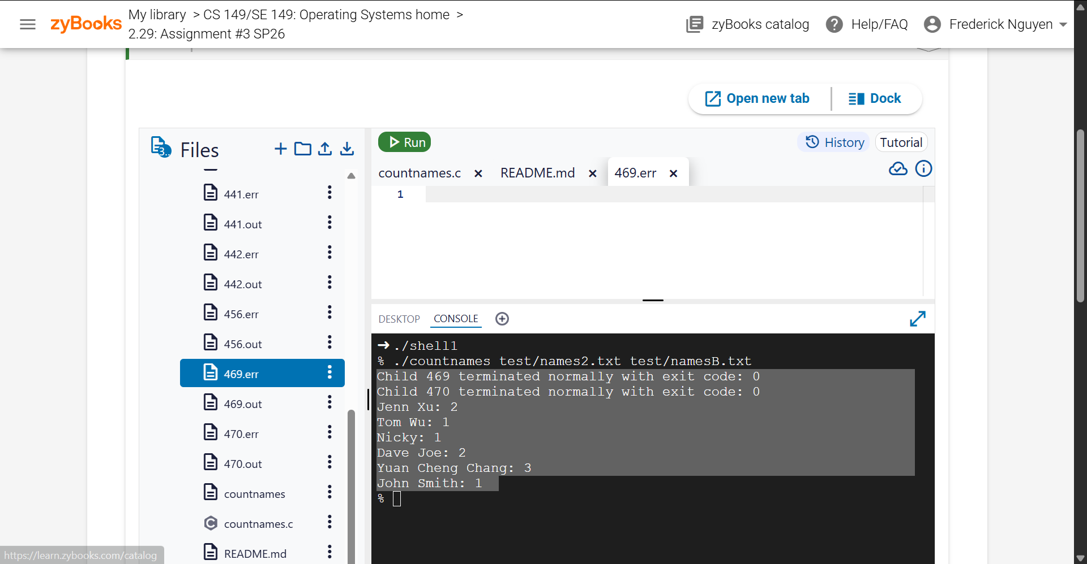

469.out

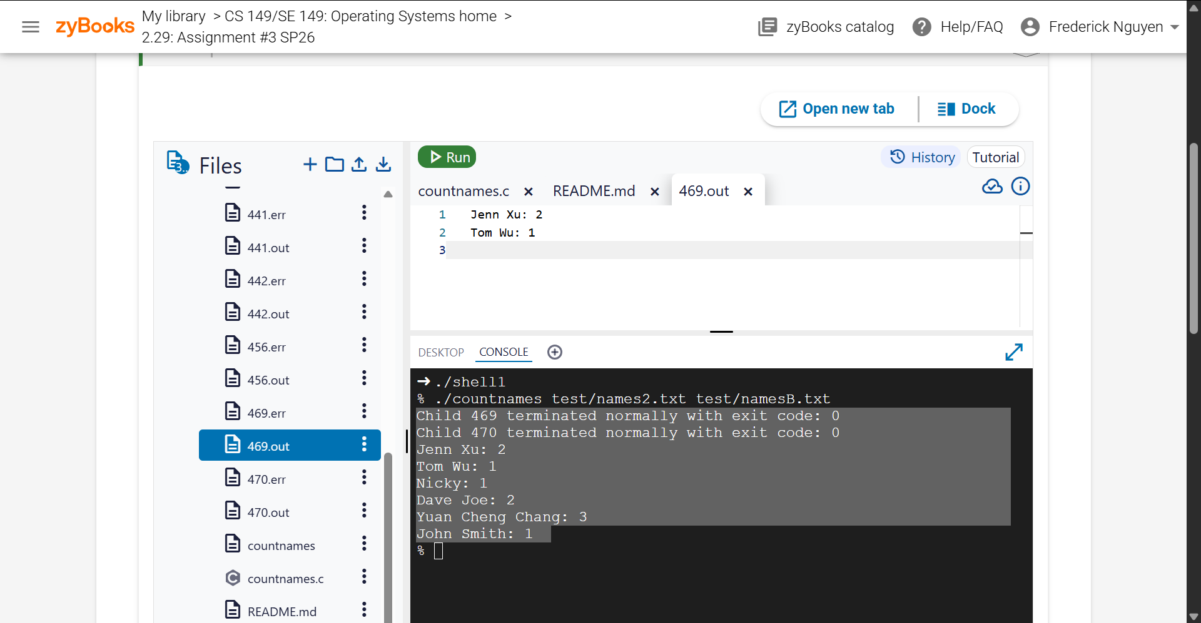

470.err

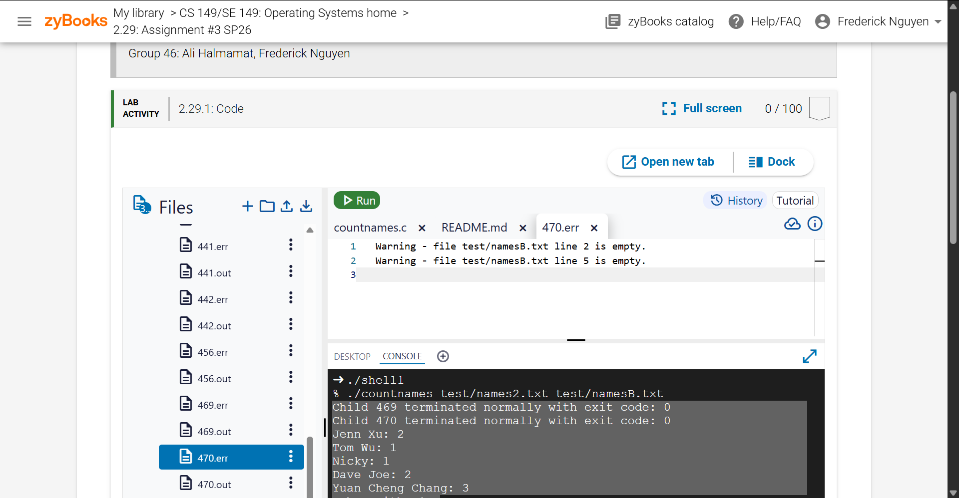

470.out

